“The purpose of the Lutheran Church of the Resurrection Endowment Fund is to enhance the work of the church by establishing new ministries and stewardship opportunities in addition to and apart from the general operation of the church and outside of the church budget.”

2023 board members were Steve Jacobson, Nicci d’Amore, Mary Hauch and Gayle Wint. We are looking for one new board member for 2024 to make up the required five member board. Please contact Steve Jacobson or the church office if you are interested and are willing to share your talents with us.

Beginning Fund balances were:   
 Fidelity: $164,514.11, Racine Community Foundation: $28,937.54\*, Total Fund balance: $193,451.65  
Year End Fund balances were:   
 Fidelity: 189,517.57, Racine Community Foundation: $28,937.54\*, Total Fund balance: $218,455.11  
Contributions to the corpus (principal) were $2,159.00 giving a total Fund corpus of $135,277.65  
Total investment return (less contributions) of the Fund for the year was 10.6%

Contributions received were a bright spot again this year. A record of over 35 contributors donated to the Fund. Over 30 contributions were given in memory of Ken Fehl. We are truly blessed and deeply thank the donors for their generosity.

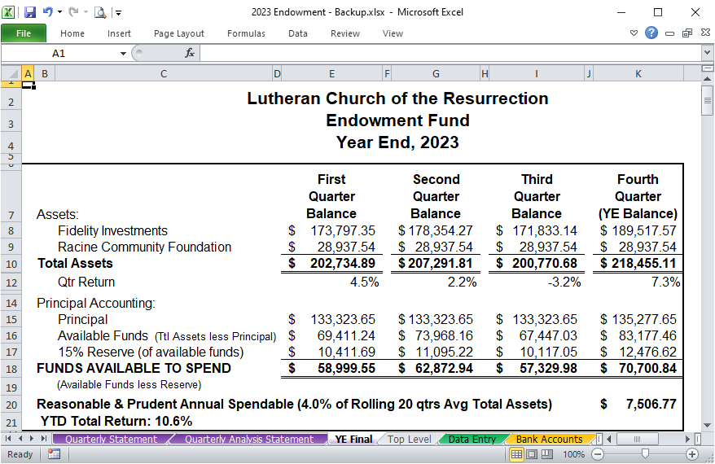

As always, any gift to the Endowment Fund remains forever, generating income that will serve to advance the church and its mission in perpetuity. Any questions about the Endowment Fund or its operation can be directed to Steve Jacobson.

Respectfully submitted,  
Steve Jacobson  
Endowment Board Chair

\* Racine Community Foundation fund balances are not reported until March. Beginning balance is YTD balance.